CerviGrade
A Deep Learning-Based Severity Grading System for Cervical Cytology Screening in Resource-Limited Settings
BSc. in Software Engineering
Wagner Mushayija
Supervisor: Marvin Ogore
September 2026

Table of Contents
List of Tables
List of Figures
List of Acronyms/Abbreviations
Abstract
Chapter One: Introduction
1.1 Introduction and Background
1.2 Problem Statement
1.3 Project's Main Objective
1.3.1 Specific Objectives
1.4 Research Questions
1.5 Project Scope
1.6 Significance and Justification
1.7 Research Budget
1.8 Research Timeline
Chapter Two: Literature Review
2.1 Introduction
2.2 Review of Related Work
VIA and Colposcopy-Based Systems
Cytology and Histopathology-Based Systems
Field-Wide Reviews
2.2.1 Summary of Reviewed Literature
2.3 Strengths and Weaknesses of Existing System(s)
2.4 General Comment and Conclusion
Chapter Three: System Analysis and Design
3.1 Introduction
3.2 Functional and Non-Functional Requirements
3.3 Research Design and Development Model
3.4 System Architecture
3.5 Data Definition and Acquisition
3.6 Machine Learning Training Pipeline
3.7 Model Comparison and Architecture Justification
3.8 UML Diagrams
3.8.1 Use Case Diagram
3.8.2 Class Diagram
3.8.3 Entity-Relationship Diagram
3.8.4 Sequence Diagram
3.9 Development Tools
References

List of Tables
Table 1. Research Budget
Table 2. Research Timeline (12-Week Cycle)
Table 3. Summary of Reviewed Literature
Table 4. Functional Requirements
Table 5. Non-Functional Requirements

List of Figures
Figure 3.1. CerviGrade System Architecture
Figure 3.2. CerviGrade Development Model
Figure 3.3. Use Case Diagram
Figure 3.4. Class Diagram
Figure 3.5. Entity-Relationship Diagram
Figure 3.6. Sequence Diagram — Grading a VIA-Positive Slide

List of Acronyms/Abbreviations
Acronym | Meaning
AI | Artificial Intelligence
API | Application Programming Interface
ASC | Atypical Squamous Cells
AUC | Area Under the Curve
AVE | Automated Visual Evaluation
CIN | Cervical Intraepithelial Neoplasia
CLIA | Clinical Laboratory Improvement Amendments
CNN | Convolutional Neural Network
Grad-CAM | Gradient-weighted Class Activation Mapping
HPV | Human Papillomavirus
LBC | Liquid-Based Cytology
ERD | Entity-Relationship Diagram
JWT | JSON Web Token
LEEP | Loop Electrosurgical Excision Procedure
MLOps | Machine Learning Operations
MOH | Ministry of Health
PLIP | Pathology Language and Image Pre-training
SSL | Self-Supervised Learning
UML | Unified Modeling Language
VIA | Visual Inspection with Acetic Acid
WHO | World Health Organization

Abstract
Cervical cancer is the leading cause of cancer death among Rwandan women of all ages and the leading cause of both incidence and death among women aged 15 to 44, with an estimated 1,229 new cases and 829 deaths annually. Visual inspection with acetic acid (VIA) is Rwanda's frontline screening test, but a positive result leads straight to cryotherapy, excision, or biopsy, with no graded laboratory step in between. Grading a cytology slide by hand is unrealistic: Rwanda had only 16 pathologists nationally as of 2019. This project proposes CerviGrade, a deep learning system that grades the severity of cervical cell abnormalities from a stained cytology slide, inserted between a positive VIA result and the treatment or biopsy decision that currently follows on visual impression alone. Four pretrained models will be compared: three convolutional neural networks, EfficientNetB0, ConvNeXt, and RegNet, fine-tuned first on a general cell-type dataset and then on two severity-graded datasets, plus PLIP, already pretrained on pathology images rather than generic photographs and evaluated through a lighter feature-extraction approach. A Grad-CAM layer will show which part of a cell image drove each grade. The project aims to benchmark the models against a minimum weighted F1-score of 0.75, with per-class sensitivity tracked for the most severe grade, and to evaluate the resulting prototype with at least five healthcare practitioners in Kigali. It is hypothesized that a fine-tuned, domain-appropriate model can grade cervical cytology severity accurately enough to reduce unnecessary biopsy referrals among VIA-positive women without requiring additional specialist staff.

Chapter One: Introduction

1.1 Introduction and Background
Cervical cancer accounts for an estimated 604,000 new cases and 280,000 deaths worldwide each year and remains the leading cause of cancer death among women in 26 countries, most of them in sub-Saharan Africa (World Health Organization, 2026). The World Health Organization attributes this concentration to unequal access to HPV vaccination, screening, and treatment services rather than to any biological difference in disease risk (World Health Organization, 2026).
Rwanda illustrates both the burden and the gap. An estimated 1,229 women are diagnosed with cervical cancer and 829 die from it every year, giving the country an age-standardized incidence rate of 28.2 per 100,000 women (HPV Information Centre, 2023). Breast cancer is Rwanda's most commonly diagnosed cancer among women overall, with cervical cancer second; but cervical cancer is the country's leading cause of cancer death among women of all ages, and both the most commonly diagnosed cancer and the leading cause of cancer death among women aged 15 to 44 (HPV Information Centre, 2023). Rwanda has made measurable progress on prevention: approximately 93% of eligible girls under 15 have received the HPV vaccine, among the highest coverage rates on the continent (Rwanda Biomedical Centre, n.d.). Screening has not kept pace. National screening coverage is estimated at 18%, against the Ministry of Health's Mission 2027 target of 70% of women aged 30 to 49 (Rwanda Biomedical Centre, n.d.).
Rwanda's frontline screening method is visual inspection with acetic acid (VIA): a nurse applies diluted vinegar to the cervix and looks for the white patches that mark abnormal tissue. VIA is inexpensive and needs no laboratory, which is why it has anchored Rwanda's screening program since 2014 (Rwanda Ministry of Health, 2024). A positive VIA result currently leads directly to cryotherapy or loop electrosurgical excision at the same visit, or to a referral for biopsy when invasive disease is suspected; a graded cytology result does not feature anywhere in that pathway. This is confirmed independently by Rwanda's 2013 national screening campaign, in which 177 of 764 screened women tested VIA-positive and went on to immediate cryotherapy or biopsy with no cytology step in between (Umulisa et al., 2018); by a study at a Rwandan tertiary hospital, where VIA-positive women went straight to colposcopy-directed biopsy (Ruzigana et al., 2017); and by Rwanda's own National Cancer Control Plan (Rwanda Biomedical Centre, 2020). The specialists who could provide that missing grading step are in short national supply: as of 2019, only 16 pathologists were working in Rwanda's public hospitals (Rwanda Biomedical Centre, 2020), and reading a stained cytology slide requires five to ten years of training beyond that (Wu et al., 2024). Staffing a new manual cytology step with that workforce, on top of its existing caseload, is not realistic; a graded step added to this pathway has to be machine-read to be feasible at all.
Software-based grading has already closed a comparable gap elsewhere in medicine. In diabetic retinopathy, deep learning models trained on retinal photographs now grade disease severity with accuracy comparable to human specialists (Gulshan et al., 2016). A similar approach is technically established for cervical cytology: convolutional neural networks trained on stained cell images can classify abnormal cells, and a 2024 hospital deployment cut first-pass cytology screening to roughly 10 seconds per case (Kurita et al., 2024). What has not yet been built is a system placed specifically where Rwanda's own screening pathway currently has no graded step at all: between a positive VIA result and the treatment or biopsy decision that currently follows it on visual impression alone.

1.2 Problem Statement
A positive VIA result in Rwanda's screening pathway does not currently pass through a graded laboratory assessment before a treatment or biopsy decision is made. Three independent sources confirm this. Umulisa et al. (2018) documented Rwanda's 2013 national screening campaign directly: of 764 women screened, 177 tested VIA-positive and were recalled for a second visit, where they received either immediate cryotherapy or a cervical biopsy, with no cytology step in between. Ruzigana et al. (2017) found the same pattern at a Rwandan tertiary hospital, where VIA-positive women proceeded straight to colposcopy-directed biopsy. Rwanda's own National Cancer Control Plan describes treatment of precancerous lesions occurring "at the time of diagnosis," with biopsy reserved for suspected invasive cases, and does not mention cytology at any stage (Rwanda Biomedical Centre, 2020). Rwanda's current pathway treats or biopsies on the strength of a nurse's visual impression alone, and every VIA-positive woman referred for biopsy undergoes a more invasive procedure than a cytology sample would require.
A cytology-based triage step would also need trained readers, and manual cytology reading is slow even where readers are not scarce. Patients in well-resourced health systems are told results can take up to three weeks to reach their provider (Cleveland Clinic, n.d.), and before the United Kingdom's National Health Service ran a dedicated process-improvement programme, its own cytology services averaged 24 days per result, with some cases taking as long as 44 (NHS England, 2017). Rwanda has far fewer trained readers than the systems behind those figures: interpreting a cervical cytology slide "requires well-trained cytologists, pathologists, and specialists with at least 5-10 years of experience" (Wu et al., 2024), and a 2026 review of the field reaches the same conclusion (Stanek-Widera et al., 2026). As of 2019, only 16 pathologists worked in Rwanda's public hospitals nationally (Rwanda Biomedical Centre, 2020). Regulatory guidance elsewhere reinforces why this cannot simply be solved by working faster: the Clinical Laboratory Improvement Amendments cap a single cytotechnologist at 100 slides per eight-hour day specifically to protect screening accuracy (U.S. Department of Health and Human Services, 1992), meaning added throughput has to come from added capacity, not added speed. A workforce of 16, adding a step it has never staffed before, would not be reading results faster than the systems above manage today.
Artificial intelligence has already been applied to cervical cancer screening, but not in a way that fills this specific gap. One line of research trains models on VIA or colposcopy photographs taken after applying acetic acid, and depends entirely on the vinegar reaction the camera is trained to detect (Hu et al., 2019, 2020, 2024). A second line trains models on stained cytology or biopsy slides and reports strong laboratory accuracy, in some cases above 90% (Cheng et al., 2021; Mohammadi et al., 2024), but a 2023 systematic review of this literature found that almost none of it explains its own reasoning or has been tested in a live clinic rather than a research dataset (Jiang et al., 2023), and a 2026 review reached the same conclusion about explainability, validation, and the scarcity of open datasets (Stanek-Widera et al., 2026). None of the reviewed systems is built to sit at the specific point in Rwanda's pathway where a graded step is currently missing: between a positive VIA test and the treatment or biopsy decision that follows it.
This project addresses these three problems by developing CerviGrade, a deep learning system that grades the severity of cervical cell abnormalities from a stained cytology slide. The system is inserted as a new triage step in Rwanda's own screening pathway, between a positive VIA result and the treatment or biopsy decision that currently follows it on visual impression alone, so that decision is informed by a graded cytology result and fewer women are referred for a biopsy a cytology grade would have shown to be unnecessary. Because reading that slide by hand would require specialists Rwanda does not have in sufficient number, the grading has to be automated to be added at all. The system compares four pretrained models, three general-purpose convolutional neural networks and one model already pretrained on pathology images, on three public, severity-labeled datasets, adds a Grad-CAM explanation layer so a clinician can see which part of a cell image drove each grade, and is evaluated with practitioners in Kigali rather than on laboratory accuracy alone.

1.3 Project's Main Objective
The main objective of this project is to develop a deep learning-based software system that grades the severity of cervical cell abnormalities from cytology slide images, in order to provide a graded, same-day laboratory result for women who screen positive on VIA, at the point in Rwanda's current screening pathway where that result does not yet exist.

1.3.1 Specific Objectives
To review the existing literature, datasets, and deployed systems relevant to AI-assisted cervical cancer screening, and to prepare the CRIC, SIPaKMeD, and Mendeley cytology datasets for model training, within the first four weeks of the project.
To develop and benchmark four pretrained models, three convolutional neural networks from distinct design families (EfficientNetB0, ConvNeXt, and RegNet) fine-tuned first on SIPaKMeD and then on each severity-graded dataset, plus PLIP, a model already pretrained on pathology images and evaluated through feature extraction rather than full fine-tuning, incorporating a Grad-CAM explanation layer, and to select the best-performing model based on weighted F1-score and per-class sensitivity for the most severe grade, within eight weeks of project commencement.
To evaluate the resulting prototype against a minimum weighted F1-score of 0.75 on a held-out test set, and to conduct a usability evaluation with at least five healthcare practitioners in Kigali on the system's clinical usefulness and workflow fit, within the final four weeks of the twelve-week project cycle.

1.4 Research Questions
To what extent can a fine-tuned deep learning model grade the severity of cervical cell abnormalities using the CRIC, SIPaKMeD, and Mendeley cytology datasets?
Which of EfficientNetB0, ConvNeXt, RegNet, and the domain-pretrained PLIP model achieves the highest classification performance on this task, as measured by weighted F1-score, per-class sensitivity, accuracy, and AUC?
Does adding a Grad-CAM explanation layer change how healthcare practitioners in Kigali perceive the trustworthiness and clinical usefulness of the system's grading?
What adaptations are needed to insert this grading step into Rwanda's existing VIA-based screening pathway without disrupting current triage and treatment workflows?

1.5 Project Scope
This project is scoped to a twelve-week capstone cycle and is bounded accordingly. Model development draws on three publicly available, pre-labeled datasets: CRIC, SIPaKMeD, and the Mendeley liquid-based cytology dataset. No new patient data collection or biopsy sampling will take place in this phase. Training will fine-tune three pre-trained convolutional neural network architectures using cloud GPU resources and evaluate one pathology-domain pretrained model through feature extraction; no novel architecture is proposed. The software deliverable is a web-based prototype that accepts a cytology slide image and returns a severity grade, a confidence score, and a Grad-CAM heatmap; it will not integrate with any hospital's electronic health records or live clinical systems at this stage. The usability evaluation will draw on a purposive sample of five to ten healthcare practitioners or laboratory staff in Kigali, and is intended as formative feedback rather than a statistically representative clinical trial. Real-time patient testing, regulatory approval, and large-scale deployment fall outside this project's scope and would form a later phase of work.

1.6 Significance and Justification
A working prototype would give Rwandan clinics a graded laboratory result at the exact point where VIA-positive women currently receive none, reducing how many are referred for an invasive biopsy on visual impression alone, without asking a national workforce of 16 pathologists to staff a new manual reading step.
The explainability layer directly answers a gap that two independent reviews of this field have identified: that most existing models give no indication of how they reached a grading decision (Jiang et al., 2023; Stanek-Widera et al., 2026).
Testing the prototype with practitioners in Kigali, rather than reporting laboratory accuracy alone, would add a data point largely missing from the current literature, which has evaluated comparable systems mainly in high-income settings.

1.7 Research Budget
Table 1 lists the items this project requires that cannot be substituted with a free alternative.
Item | Estimated Cost (USD) | Notes
Cloud GPU compute (Google Colab Pro or equivalent) | 50 | Approximately two months, for model training and comparison
Web hosting for the prototype | 20 | Basic hosting for the demonstration period

1.8 Research Timeline
Table 2 presents the planned twelve-week schedule.
Phase | Weeks 1-2 | Weeks 3-4 | Weeks 5-6 | Weeks 7-8 | Weeks 9-10 | Week 11 | Week 12
Literature review & dataset preparation | X
Data preprocessing & augmentation |  | X
Model training (4 models) |  |  | X
Model evaluation, selection & Grad-CAM integration |  |  |  | X
Web prototype development |  |  |  |  | X
Usability evaluation with practitioners in Kigali |  |  |  |  |  | X
Final documentation & report |  |  |  |  |  |  | X

Chapter Two: Literature Review

2.1 Introduction
This chapter reviews software-related literature on artificial intelligence applications in cervical cancer screening. The search targeted peer-reviewed papers and technical reports describing a deployed or evaluated software system, rather than purely clinical or epidemiological studies. Sources were located through Google Scholar, PubMed, IEEE Xplore, ScienceDirect, arXiv, and the publisher platforms of Nature, Springer, Wiley, MDPI, and PLOS, using combinations of the terms "cervical cancer," "deep learning," "cytology," "colposcopy," "Pap smear," and "artificial intelligence." Twenty sources published between 2019 and 2026 were selected for detailed review and are organized below by the screening modality and system type each one addresses.

2.2 Review of Related Work
Several software systems already attempt some part of AI-assisted cervical cancer screening, though none is built for the specific point in Rwanda's pathway this project targets. They fall into two groups by what they read: a photograph of the cervix taken during a VIA exam or colposcopy, or a stained cytology or biopsy slide.

VIA and Colposcopy-Based Systems
Hu, Bell, Antani, et al. (2019) trained a Faster R-CNN model on cervix photographs from a seven-year study of 9,406 women in Costa Rica, achieving an AUC of 0.91 against 0.71 for standard Pap smear reading in the same cohort. The photographs were taken with a since-discontinued film camera technique, and the authors themselves called for retesting on modern digital cameras. Hu, Horning, Banik, et al. (2020) engineered a smartphone version of this system, the Automated Visual Evaluation (AVE) tool, with an added image-quality check; the engineering build ran on a Samsung J8 smartphone in about 30 seconds per photo, but clinical field testing was reported as still in progress, and the tool produces a binary result with no severity grade. Hu et al. (2024) later validated AVE prospectively across eight clinics in Zambia, testing it on 8,204 women and outperforming standard VIA at 85% versus 66% detection, though only against the same patients and phones used in training, leaving cross-country and cross-device performance unconfirmed. AVE depends entirely on the vinegar reaction a VIA exam produces and has no equivalent signal to detect on a cytology slide.
Harsono et al. (2022) built IVANET, an Android application that scores a VIA photograph using gradient boosting rather than a neural network, tested on a sample of 199 women with 80% sensitivity and 96.4% specificity, validated against an oncologist's visual opinion rather than a histopathology-confirmed result. Like AVE, it works only on VIA images and returns a binary result. Chandran, Sumithra, Karthick, et al. (2021) applied an ensemble of deep learning models to colposcopy images, using several models' combined vote rather than a single classifier; the paper's exact accuracy figures could not be confirmed past its paywall and should be verified directly before being cited with specific numbers. Himabindu, Lydia, Rajesh, Ahmed, and Ishak (2025) took a newer-architecture approach on the same modality, using a Swin Transformer for feature extraction ahead of an ensemble classifier on colposcopy images, reporting 99.44% accuracy; the result comes from a single public dataset of only 600 images, with no multi-center validation. Desai et al. (2022) contributed a perspective piece specifically on the difficulty of moving AVE-style tools from a research setting into a functioning clinic, adding expert opinion rather than new results.

Cytology and Histopathology-Based Systems
Cheng, Liu, Yu, et al. (2021) built a whole-slide image system trained on 3,545 slides from five hospitals, reaching 95.1% sensitivity and 93.5% specificity, but requiring an expensive professional slide scanner, a dedicated GPU, and giving only a positive-or-negative output rather than a severity grade; the authors reported weaker performance on HPV-positive cases and called for a lower-cost, portable-microscope version. Abinaya and Sivakumar (2024) combined a 3D CNN with a Vision Transformer, evaluated only on the single-hospital Herlev dataset. Kurita et al. (2024) deployed an AI triage system at a Japanese hospital that ranks cervical cytology slides by an anomaly score rather than issuing a diagnosis, cutting first-pass screening to roughly 10 seconds per case across 938 real specimens, though the system reads weaker on borderline atypical cases and has only been validated at that one site. Mohammadi et al. (2024) built a comparable system for cervical tissue biopsies, grading severity on a normal-to-cancer scale with 93.4% sensitivity for malignant cases and a per-slide processing time of about 1.5 minutes against a pathologist's 5 minutes, on biopsy tissue rather than cytology smears. Both add a workload dimension the VIA-based papers do not: measured screening or reporting time rather than accuracy alone, though neither is built around a VIA-first screening pathway.
A more recent group of studies moves past the architectures above. Tang, Zhang, Gong, and Huang (2023) fine-tuned ConvNeXt-tiny, a 2022 redesign of the classic convolutional network, on 8,619 images drawn from 1,167 specimens in the Deep Cervical Cytological Levels dataset, reporting an 8.85% accuracy improvement over prior architectures, though evaluated on that single dataset only. Vani and Rama Rao (2025) paired EfficientNet with a Multi-Verse Optimizer and an entropy-based classifier on SIPaKMeD, reaching 99.43% accuracy, again on one dataset. Stegmüller et al. (2023) pretrained a model using DINO, a self-supervised method that needs no manual labels, on 1.5 million unlabeled cervical cell tiles from an in-house Swiss dataset, then evaluated it on Herlev and SIPaKMeD; the self-supervised model matched or beat an ordinary ImageNet-pretrained baseline by as much as 16 points of F1-score, direct evidence that pretraining on the right kind of image, not just the right architecture, measurably changes performance on this task, though neither the pretraining data nor the resulting model were released publicly. Huang, Li, Kan, Liu, and Liang (2024) went a step further and used existing pathology foundation models, including PLIP, as ready-made feature extractors for a whole-slide cervical screening system, reaching 99.69% AUC on a 2,625-slide in-house dataset without training a classifier from scratch; this is the closest precedent in the literature for the domain-pretrained model this project also tests, though their system classifies a whole slide as positive or negative rather than grading individual cell severity. Tran, Pham, Trinh, et al. (2026) layered Grad-CAM heatmaps onto several CNN architectures specifically to compare accuracy against explanation quality, though the publicly available summary of that work does not report which dataset or exact accuracy figures were used.

Field-Wide Reviews
Jiang et al. (2023) reviewed the deep learning cervical cytology literature from cell-level identification through whole-slide analysis and concluded that most published models neither explain their own reasoning nor have been tested in a real clinic outside the dataset they were trained on. Wu, Lucas, Zhao, Basu, and Qiao (2024) reviewed the same field from a workforce angle, concluding that AI's clearest value is in low-resource settings, where trained cytologists and pathologists are scarce. Stanek-Widera et al. (2026), the most recent cervix-specific review located, reached the same three conclusions two years later: most models remain black boxes, most are validated only retrospectively rather than in live clinical use, and large open datasets remain scarce. Outside the cervical cancer literature specifically, Salehi et al. (2023) surveyed convolutional neural network and transfer-learning architectures across medical imaging generally, including VGG, ResNet, and DenseNet variants, and found that no single architecture family wins consistently across tasks and datasets; the review runs no new experiments and was not written with cervical cytology in mind, but it is the general-architecture context this project draws on in Chapter Three, rather than a single prior benchmark's already-computed result for this exact task.

2.2.1 Summary of Reviewed Literature
# | Author(s) & Year | Modality | Key Result | Principal Gap
1 | Hu, Bell, Antani, et al. (2019) | VIA / colposcopy | AUC 0.91 vs. 0.71 for Pap smear, 9,406 women | Outdated film camera; binary output only
2 | Hu, Horning, Banik, et al. (2020) | VIA / colposcopy | Runs on smartphone in ~30 sec/photo | Field testing incomplete; no severity grade
3 | Hu et al. (2024) | VIA / colposcopy | 85% vs. 66% detection, 8,204 women, Zambia | Internal validation only
4 | Harsono et al. (2022) | VIA / colposcopy | 80% sensitivity, 96.4% specificity, n=199 | Small sample; binary; not deep learning
5 | Chandran, Sumithra, Karthick, et al. (2021) | VIA / colposcopy | Ensemble voting on colposcopy images | Exact figures unverifiable behind paywall
6 | Himabindu, Lydia, Rajesh, et al. (2025) | VIA / colposcopy | 99.44% accuracy, Swin Transformer ensemble | 600-image single dataset; no multi-center test
7 | Desai et al. (2022) | VIA / colposcopy (perspective) | Discussion of lab-to-clinic translation | No new experimental results
8 | Cheng, Liu, Yu, et al. (2021) | Cytology (whole-slide) | 95.1% sensitivity, 3,545 slides, 5 hospitals | Needs expensive scanner; binary output
9 | Abinaya & Sivakumar (2024) | Cytology | 3D CNN + Vision Transformer on Herlev | Single dataset, single hospital
10 | Kurita et al. (2024) | Cytology | ~10 sec/case, 938 specimens, 1 hospital | Weak on ASC cases; single-site validation
11 | Mohammadi et al. (2024) | Histopathology (biopsy) | 93.4% sensitivity; 1.5 vs. 5 min/slide | Biopsy tissue, not cytology smears
12 | Tang, Zhang, Gong, & Huang (2023) | Cytology | ConvNeXt-tiny, +8.85% accuracy over prior work | Single dataset (DCCL) only
13 | Vani & Rama Rao (2025) | Cytology | EfficientNet + optimizer, 99.43% accuracy | Single dataset (SIPaKMeD) only
14 | Stegmüller et al. (2023) | Cytology (self-supervised) | SSL pretraining beat ImageNet by up to 16 F1 pts | Pretraining data and model not released
15 | Huang, Li, Kan, Liu, & Liang (2024) | Cytology (foundation models) | 99.69% AUC using PLIP as a feature extractor | Whole-slide positive/negative only, not graded
16 | Tran, Pham, Trinh, et al. (2026) | Cytology + explainability | Grad-CAM across multiple architectures | Dataset and accuracy not disclosed
17 | Jiang et al. (2023) | Review (cytology field) | Systematic review of the field | No explainability; no real-clinic testing
18 | Wu, Lucas, Zhao, Basu, & Qiao (2024) | Review (workforce) | States the 5-10 year training requirement | Review only; no new system
19 | Stanek-Widera et al. (2026) | Review (cytology field) | Confirms 2023 review's gaps, 2 years on | Black-box models; scarce open datasets
20 | Salehi et al. (2023) | Review (general medical imaging) | No architecture family wins consistently | Not cervix-specific; no new experiments

2.3 Strengths and Weaknesses of Existing System(s)
Across both branches of this literature, three strengths recur. Laboratory accuracy is consistently high, often above 90% (Cheng et al., 2021; Tang et al., 2023; Vani & Rama Rao, 2025; Mohammadi et al., 2024). Several systems have moved beyond a laboratory bench test into an actual clinical or field deployment (Hu et al., 2024; Kurita et al., 2024; Harsono et al., 2022). And explainability, absent from the field as recently as 2023 (Jiang et al., 2023), is now an active area of work (Tran et al., 2026).
Three weaknesses also recur. Most systems that grade severity have been validated at a single hospital or on a single dataset, with no test of how they perform on a different population, camera, or laboratory protocol (Abinaya & Sivakumar, 2024; Kurita et al., 2024; Cheng et al., 2021). Systems built for VIA or colposcopy images cannot be repurposed for cytology, because their entire signal depends on the vinegar reaction (Hu et al., 2019, 2020, 2024; Harsono et al., 2022). And no reviewed system, whatever its accuracy, is built around the specific triage point this project targets: the gap between a positive VIA result and a treatment or biopsy decision in a low-resource, VIA-first screening pathway.

2.4 General Comment and Conclusion
Limited studies address AI-assisted grading of cervical cytology within a screening pathway that starts with VIA rather than HPV testing, and fewer still combine severity grading, an explainability layer, and evaluation with practitioners outside a single hospital. CerviGrade is positioned in that space. It does not compete with the VIA-based or colposcopy-based literature, because it targets the confirmatory step that literature does not address, and it extends the cytology-based literature by adding the explainability and field-testing components that Jiang et al. (2023) and Stanek-Widera et al. (2026) both identify as missing.

Chapter Three: System Analysis and Design

3.1 Introduction
This chapter turns the case built in Chapters One and Two into a concrete design. It sets out the functional and non-functional requirements the system must satisfy, the development model guiding the work, the system architecture that CerviGrade will be built on, the datasets that will train it, the training pipeline itself, the reasoning behind comparing four pretrained models rather than adopting one from prior work, and four UML diagrams describing the system's structure and behavior.

3.2 Functional and Non-Functional Requirements
The requirements below follow directly from the architecture and workflow described later in this chapter, rather than being stated first and designed around afterward; Table 4 and Table 5 are restated here as a single reference point because an earlier draft of this chapter never made them explicit.
Table 4. Functional Requirements
ID | The system shall...
FR1 | Allow a lab technician to upload a batch of field images captured in a fixed scanning pattern across a patient's slide.
FR2 | Preprocess each uploaded image by resizing it and normalizing its stain color before analysis.
FR3 | Run a coarse scan across each field image, sliding a cell-sized window over it, to flag any region that looks abnormal.
FR4 | Crop each flagged region and classify it with the selected model to produce a confirmed severity grade and confidence score.
FR5 | Generate a Grad-CAM heatmap (or an attention-map visualization, if the deployed model is PLIP) for each confirmed grade, showing which part of the flagged region drove it.
FR6 | Report the single most severe confirmed grade found across the whole batch as the patient's result, or a normal result if nothing is flagged.
FR7 | Display the grade, its confidence score, and the heatmap to a clinician for review.
FR8 | Allow a clinician to confirm or correct a reported grade.
FR9 | Log clinician feedback against the corresponding prediction for future reference.
FR10 | Allow a data scientist to train, compare, and deploy candidate models through a separate training environment, independent of the clinical workflow above.
Table 5. Non-Functional Requirements
Category | The system shall...
Performance | Return a result for an uploaded batch within roughly 30 seconds, in line with comparable field-deployed screening tools such as AVE (Hu et al., 2020).
Usability | Require no machine learning expertise from a lab technician; using it should not take more than uploading images and reading back a result.
Security | Authenticate every request with JWT-based sessions and never store patient-identifying information, consistent with the de-identified datasets it is trained on.
Availability | Be available during clinic operating hours; no formal uptime service-level agreement is required at prototype stage, consistent with Section 1.5's scope.
Maintainability | Run as a Docker container with model versions tracked in a model registry, so a newly trained model can be deployed without redeploying the rest of the application.
Portability | Run on a single standard cloud virtual machine without specialized hardware, consistent with the research budget in Section 1.7.

3.3 Research Design and Development Model
Standard software development models assume the hardest part of a project is writing code against a fixed specification. Amershi et al. (2019), reporting on how Microsoft teams actually build machine learning products, found the opposite: teams spent most of their time on data collection and model iteration, and repeatedly cycled back through earlier stages as new evaluation results came in, rather than moving through a single linear sequence of phases. CerviGrade follows that same cyclical pattern instead of a conventional waterfall or single-pass Agile sprint plan.
The development model has six stages, several of which loop back into earlier ones as results come in: (1) reviewing the literature and selecting datasets, already completed in Chapter Two; (2) preparing and augmenting the CRIC, SIPaKMeD, and Mendeley datasets; (3) training EfficientNetB0, ConvNeXt, and RegNet first on SIPaKMeD and then separately on CRIC and Mendeley, alongside evaluating PLIP, a pathology-pretrained model, through feature extraction; (4) evaluating each against the weighted F1 and per-class sensitivity targets set in Section 1.3.1, returning to stage 2 or 3 if a target is missed; (5) integrating the best-performing model into a working prototype with the Grad-CAM explainability layer; and (6) evaluating that prototype with healthcare practitioners in Kigali, whose feedback may in turn send the project back to stage 3 for retraining.
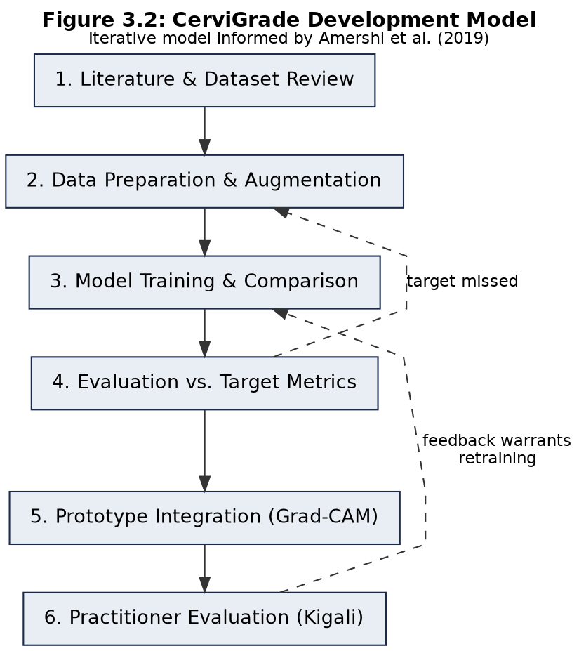
Figure 3.2. CerviGrade development model, adapted from Amershi et al. (2019).

3.4 System Architecture
Figure 3.1 sets out CerviGrade's architecture, adapted from the end-to-end MLOps pipeline pattern described by Sparr (2024). The reference pipeline is built for a production system that retrains continuously against a live stream of user corrections, and includes a Kafka message broker, a dedicated correction-processing service, and a multi-model ensemble comparison stage running at inference time. CerviGrade's serving path is deliberately simpler: it grades one patient's slide at a time for the smaller group of women a VIA result already flagged positive, not a continuous high-volume stream, so a message broker between services would add operational complexity without a matching load to justify it. A load balancer is likewise omitted for the same reason; it becomes relevant only if request volume grows beyond what a single application server handles. Comparing EfficientNetB0, ConvNeXt, RegNet, and PLIP against each other also happens once, offline, in the training notebook described in Section 3.6, rather than repeatedly at serving time. The client is a responsive web application rather than a native mobile app: unlike the VIA and colposcopy tools reviewed in Chapter Two, which photograph the cervix directly with a handheld phone camera out in the field, CerviGrade's input comes from a microscope-mounted camera at a lab bench, a setting a browser interface on a lab computer or tablet serves as well as a dedicated mobile build would, without the added cost of separate app-store releases.
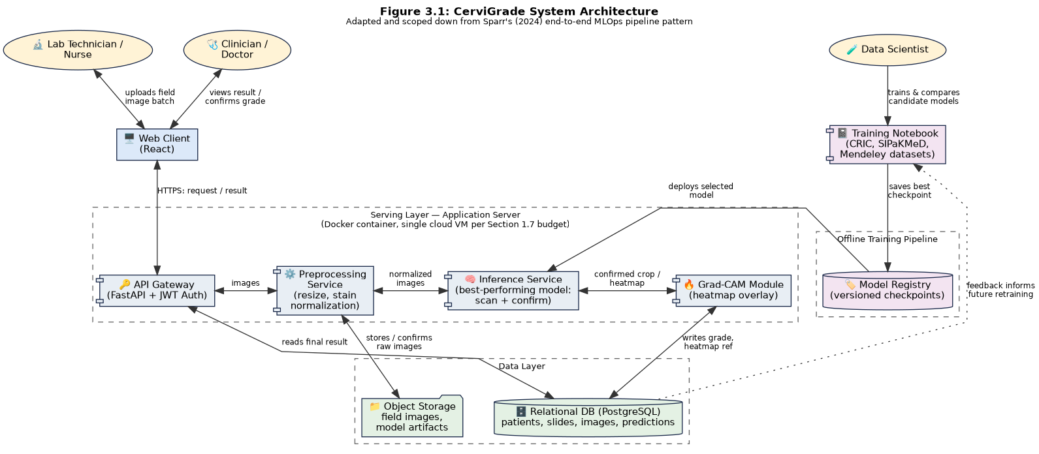
Figure 3.1. CerviGrade system architecture, adapted and scoped down from Sparr (2024).
A lab technician captures a batch of field images for a VIA-positive patient's slide, following a fixed scanning pattern across the slide rather than selecting individual cells by eye, and uploads the batch through the web client over HTTPS. The application server hosting the API gateway and the serving-layer services runs as a Docker container on a single cloud virtual machine, the compute resource named in the research budget. The API gateway authenticates the request and, over an internal HTTP call, passes each image to a preprocessing service that resizes it and normalizes its stain color, since the training datasets were captured with different microscopes and stains, and returns the normalized image. The preprocessing service then calls the inference service, which grades each field image in two passes using whichever single model won the comparison in Section 3.7: a coarse pass slides a cell-sized window across the image to flag any patch that looks abnormal, and a confirmation pass crops each flagged patch more tightly and reclassifies it to produce the grade and confidence score actually reported, since a hastily windowed crop can catch part of a neighboring cell. The inference service passes the confirmed crop to the Grad-CAM module, which overlays a heatmap on the region that most influenced that grade and returns it. Across every field image in the batch, the single most severe confirmed grade becomes the patient's reported result; a batch with nothing flagged is reported as normal. The grade, its confidence score, and the heatmap reference are written to a relational database, while the raw field images and model checkpoints sit in object storage. A clinician views the result through the same client and can confirm or correct the grade; that feedback is logged and, as future work rather than a feature this project builds, could feed a later retraining cycle. Training itself happens separately: a data scientist works in a notebook environment against the four candidate models, and the best-performing checkpoint is promoted to the model registry and deployed to the inference service.

3.5 Data Definition and Acquisition
Three public, de-identified datasets will be used, chosen because two of them already carry severity labels rather than only a binary or cell-type label, which this project's grading task requires.
CRIC dataset. Rezende et al. (2021) released 400 conventional Pap smear field images with 11,534 individually classified cells, labelled under the Bethesda System into six classes: negative for intraepithelial lesion or malignancy, atypical squamous cells of undetermined significance, low-grade and high-grade squamous intraepithelial lesion, atypical squamous cells that cannot exclude a high-grade lesion, and squamous cell carcinoma. CRIC replaces the older Herlev dataset (Jantzen et al., 2005) used in an earlier draft of this proposal for two reasons: its images show multiple cells per field rather than single pre-cropped cells, the same format the batches of field photographs described in Section 3.4 are captured in, and its Bethesda categories match the reporting scale used in practice rather than a custom grading scheme. Before training, each CRIC field image is cropped into individual cell images using the per-cell coordinates Rezende et al. (2021) provide, so the resulting training data matches SIPaKMeD and Mendeley's single-cell format; this is also what makes the same fine-tuned classifier reusable as the sliding-window scanner in Section 3.4, since it was trained on crops the same size as the window it later scans with.
SIPaKMeD dataset. Plissiti et al. (2018) at the University of Ioannina and NCSR "Demokritos" released 4,049 individual cell images cropped from 966 cluster-cell Pap smear images, categorized into five classes: superficial-intermediate and parabasal (normal), koilocytotic and dyskeratotic (abnormal), and metaplastic (a benign transformation-zone cell type). SIPaKMeD carries no severity label, so it is used differently from CRIC and Mendeley: EfficientNetB0, ConvNeXt, and RegNet are each fine-tuned on SIPaKMeD first, learning to tell cervical cell types apart in general, and that adapted checkpoint, not the original ImageNet weights, is the starting point for the separate CRIC and Mendeley fine-tuning runs described in Section 3.6.
Mendeley LBC dataset. Hussain et al. (2020) released 963 liquid-based cytology images collected from 460 patients on a Leica ICC50 HD microscope at 40x magnification, sorted into four classes under the Bethesda System. This dataset is the only one using liquid-based cytology rather than a conventional smear, giving the model exposure to a second slide-preparation method, and, like CRIC, is one of the two severity-grading targets the SIPaKMeD-adapted checkpoint is fine-tuned on.
PLIP. Alongside the three general-purpose architectures, this project evaluates PLIP (Huang, Bianchi, Yuksekgonul, Montine, & Zou, 2023), a model already pretrained on pathology images and their descriptions rather than on everyday photographs. PLIP is not fine-tuned the same way as the other three; its image encoder instead extracts a fixed set of features from each CRIC and Mendeley image, and a lightweight classifier is trained on those features, an approach called linear probing, since SIPaKMeD's cell-type warm-start is unnecessary for a model already pretrained on pathology images. This tests a different hypothesis from the other three: whether starting from pathology-domain knowledge closes more of the gap to good severity grading than starting from a bigger, better-tuned but still generic architecture. Huang, Li, Kan, Liu, and Liang (2024) used PLIP the same way, as a feature extractor rather than a fully fine-tuned network, for a different cervical cytology screening task, and Stegmüller et al. (2023) found that self-supervised pretraining on cervical cell images specifically, though not released publicly, outperformed an ordinary ImageNet-pretrained baseline on Herlev and SIPaKMeD by as much as sixteen points of F1-score; PLIP is the closest publicly available approximation of that same idea available to this project.
CRIC and Mendeley will each be split 70/15/15 into training, validation, and test sets, stratified by class so the minority classes appear in every split; SIPaKMeD is used in full for the warm-start stage rather than held out as a test set, since it is not itself a severity-grading target. Images will be resized to each architecture's expected input resolution and stain-normalized. Because the most severe classes are underrepresented in CRIC, training will apply class-weighted loss and augment the minority classes with rotation, flipping, and brightness jitter rather than leaving the imbalance uncorrected, which is the specific failure mode Wu et al. (2024) and Stanek-Widera et al. (2026) both flag as a recurring weakness in this literature.

3.6 Machine Learning Training Pipeline
EfficientNetB0, ConvNeXt, and RegNet each start from ImageNet-pretrained weights rather than random initialization, since none of the three datasets is large enough to train a network of this depth from scratch. Each is first fine-tuned on SIPaKMeD, in two phases: the convolutional base is frozen while a new five-class classification head is trained, then the final block is unfrozen and fine-tuned at a lower learning rate. The resulting SIPaKMeD-adapted checkpoint, not the original ImageNet weights, is then the starting point for two further fine-tuning runs per architecture, one on CRIC and one on Mendeley, each again following the same freeze-then-unfreeze pattern with a new classification head sized to that dataset's class count. All three architectures use the Adam optimizer, class-weighted categorical cross-entropy loss, and early stopping on validation loss to avoid overfitting on datasets this size.
PLIP is trained differently, reflecting that it already carries pathology-domain knowledge rather than needing a cervical-specific warm-start. Its image encoder is frozen throughout; each CRIC and Mendeley image is passed through it once to produce a fixed feature vector, and a lightweight classifier, logistic regression or a small multilayer perceptron depending on which performs better on the validation split, is trained on those vectors for each dataset separately. This linear-probing approach trains in a fraction of the time a full fine-tuning run takes, since the encoder's weights never change.
Every training run, eight in total across the three fine-tuned architectures on two severity datasets each, plus PLIP's two linear-probe runs, is tracked in the notebook environment shown in Figure 3.1, and the checkpoint with the best validation weighted F1-score for each run is saved to the model registry. Final selection among all eight is made on the held-out test set using the weighted F1-score and per-class sensitivity metrics defined in Section 1.3.1, not the validation set used during training, so the reported result reflects performance on data the model never influenced its own selection with. Grad-CAM applies directly to the three convolutional architectures, since it reads gradients flowing back through convolutional feature maps; PLIP's image encoder is a Vision Transformer, so if PLIP is the best-performing model, an attention-map visualization, the transformer equivalent of Grad-CAM, is substituted rather than assumed to work unchanged.

3.7 Model Comparison and Architecture Justification
EfficientNetB0, ConvNeXt, and RegNet were chosen because each represents a different design philosophy rather than a variation on the same idea. EfficientNetB0 comes from a family built around balanced, compound scaling of depth, width, and image resolution together, prioritizing accuracy per unit of computation, which suits this project's modest compute budget. ConvNeXt is a 2022 redesign of the classic convolutional network that adopted specific design choices from Vision Transformers, which had begun outperforming CNNs on several benchmarks, while remaining fully convolutional. RegNet comes from a systematic search over thousands of possible network designs rather than a hand-crafted structure. Salehi et al. (2023), reviewing convolutional and transfer-learning architectures across medical imaging generally, found that no single architecture family wins consistently across tasks and datasets; that general finding, not a single prior study's already-computed result on this exact problem, is the basis for comparing three genuinely different design philosophies rather than assuming in advance which one is best.
PLIP is included for a different reason: to test whether pretraining that already understands pathology images, rather than everyday photographs, closes more of the performance gap than architecture choice alone. Stegmüller et al. (2023) found that self-supervised pretraining on cervical cell images specifically outperformed an ordinary ImageNet-pretrained baseline by as much as sixteen points of F1-score on Herlev and SIPaKMeD, though their pretrained model was never released publicly. Huang et al. (2024) used PLIP as a feature extractor for a different cervical cytology screening task and reported strong results without any full fine-tuning at all. Neither result transfers directly here, since neither was tested on CRIC or Mendeley or on this project's severity-grading task specifically, so PLIP is trained and evaluated as a fourth candidate rather than assumed in advance to outperform the other three.
PLIP's inclusion is also this project's practical answer to self-supervised pretraining, rather than a from-scratch attempt at it. Self-supervised methods like the one Stegmüller et al. (2023) used only pay off with very large amounts of unlabeled data, in their case 1.5 million cervical cell tiles; CRIC, SIPaKMeD, and Mendeley combined offer only a few thousand images, nowhere near enough to pretrain a self-supervised encoder from scratch within a twelve-week project. PLIP was itself trained with a self-supervised-adjacent method, contrastive learning between pathology images and the text pathologists wrote about them, rather than hand-labeled examples, so evaluating it here already tests a version of the idea a proper from-scratch run would explore, using a model someone else already had the data and compute to train. A dedicated self-supervised pretraining run on cervical cytology, at the scale Stegmüller et al. (2023) used, remains future work should a larger unlabeled dataset become available.
The evaluation metrics follow the same reasoning. Weighted F1-score is the primary metric because both CRIC and Mendeley are class-imbalanced, and plain accuracy would let a model that is good at the common classes look strong while missing the rare, severe ones. Per-class sensitivity for the most severe grade is tracked separately because a false negative on a cancer-grade slide is the one error this project cannot afford to hide inside an averaged score. Accuracy and area under the curve are also recorded, per Research Question 2, but neither is the basis for choosing which of the four models to deploy.

3.8 UML Diagrams
The four diagrams below describe CerviGrade's structure and behavior in standard UML notation, drawn directly against the entities and workflow described in this chapter rather than generated independently of it.

3.8.1 Use Case Diagram
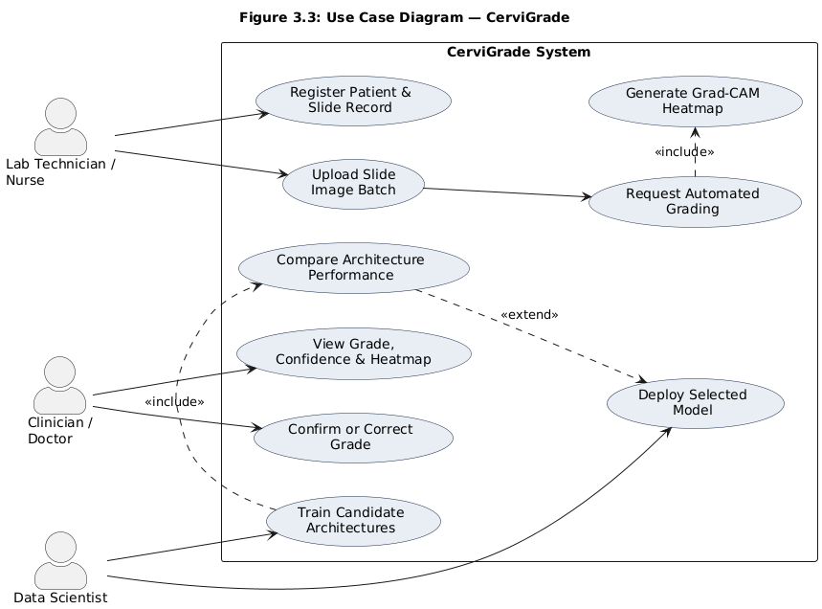
Figure 3.3. Use case diagram for CerviGrade.
Three actors interact with the system. The lab technician registers a patient's slide record and uploads a batch of field images; requesting automated grading includes generating the Grad-CAM heatmap, since a grade is not considered complete without one. The clinician views the resulting grade and confirms or corrects it. The data scientist trains and compares candidate models and deploys the selected one; comparing models extends the deployment use case rather than being a precondition of it, since a newly trained model is only deployed once it beats whatever is currently in production.

3.8.2 Class Diagram
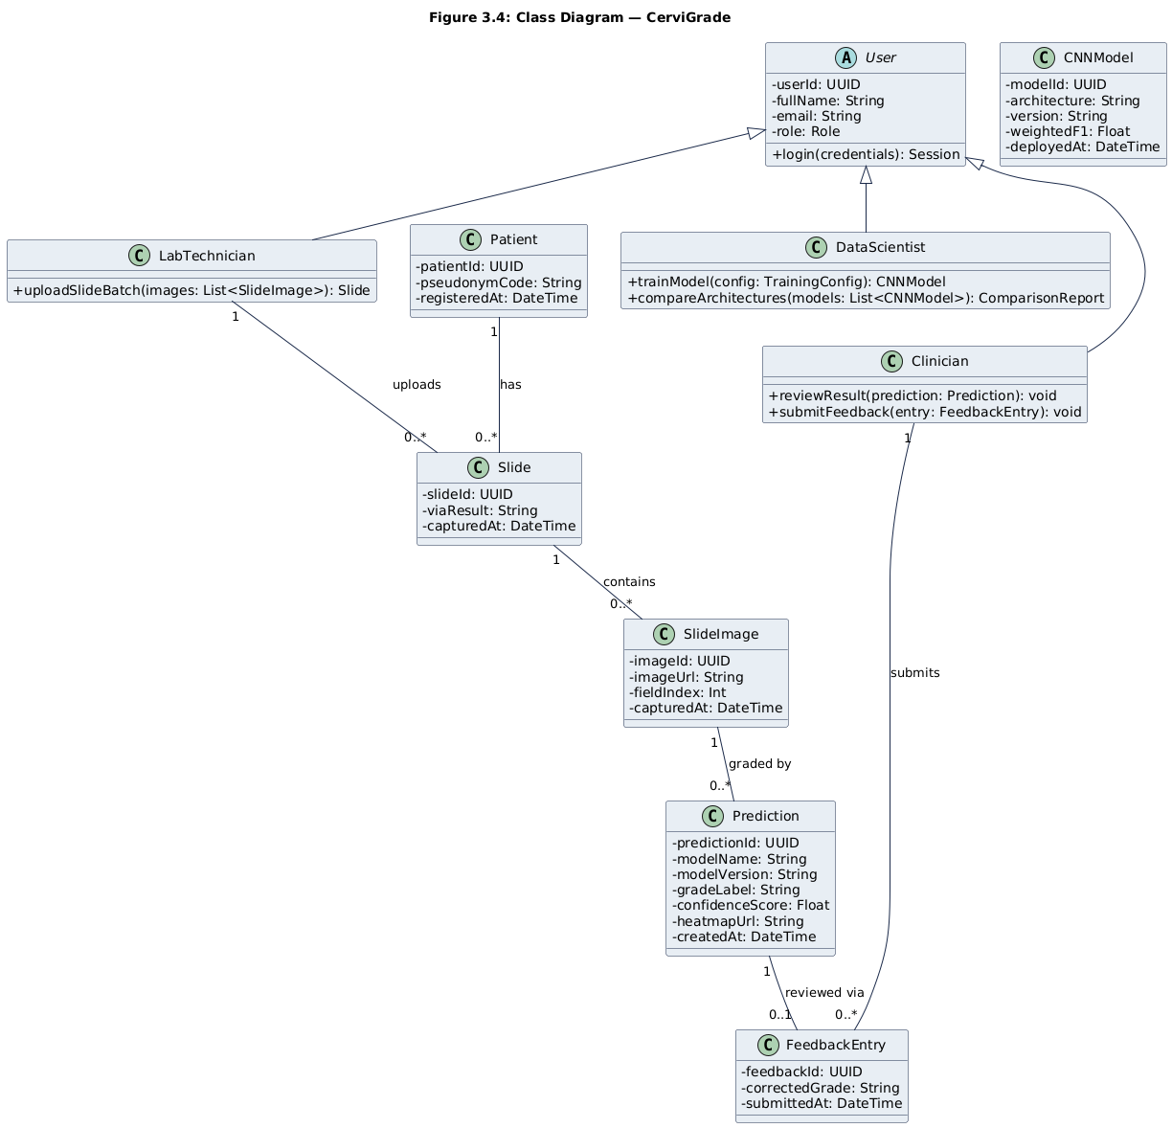
Figure 3.4. Class diagram for CerviGrade.
User is an abstract base class specialized into LabTechnician, Clinician, and DataScientist, each exposing only the operations that role performs. A Patient has many Slide records, one per screening visit; each Slide is uploaded by exactly one LabTechnician and contains many SlideImage records, one per field photograph in that visit's batch. Each Prediction belongs to exactly one SlideImage, since a grade always traces back to one specific flagged crop within one specific photograph, and carries the producing model's name and version directly as attributes rather than through a separate model class, and may have at most one FeedbackEntry attached to it, submitted by a Clinician. CNNModel still exists as a class the DataScientist trains and compares, but it is not linked to Prediction by an association, since it is a working object used during training rather than a persisted record the live system looks up.

3.8.3 Entity-Relationship Diagram
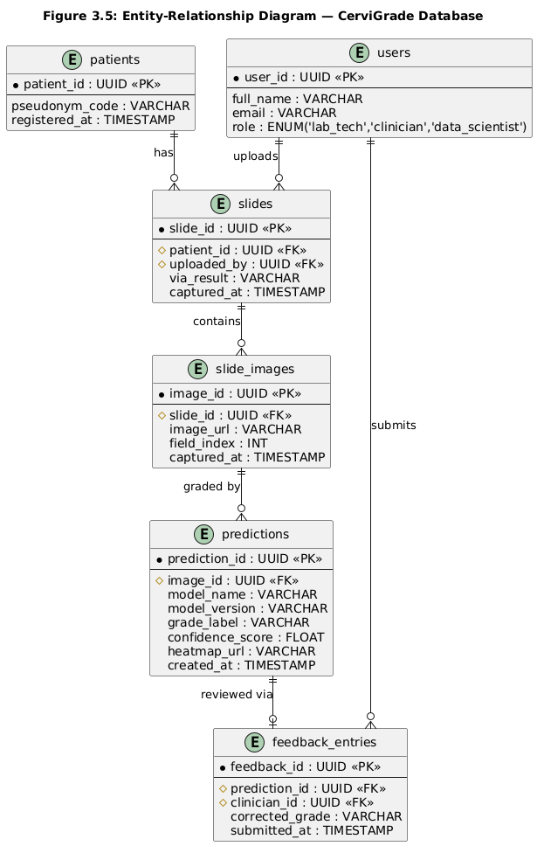
Figure 3.5. Entity-relationship diagram for the CerviGrade database.
The relational schema mirrors the class diagram, and clarifies two points raised during review. First, users and patients are deliberately separate tables because they represent different kinds of people: users are the lab technicians, clinicians, and data scientists who log in and operate the system, while patients are the women being screened, identified only by a pseudonym code and never given login access, consistent with the de-identified data this project uses. Second, there is no models table; an earlier version of this schema included one, which implied the database stores trained model weights, when in fact those weights live in the model registry and object storage shown in Figure 3.1. Instead, predictions carries the producing model's name and version directly as plain fields, enough to trace which model made a given grade without a table that reads as though it holds the model itself. slides holds foreign keys to both patients and users, recording who uploaded a given patient's batch; slide_images holds one row per field photograph in that batch, referencing the slide it belongs to. predictions references slide_images rather than slides directly, since a grade is meaningless without knowing which specific photograph, not just which visit, it was computed from. feedback_entries references both predictions and users, capturing which clinician corrected which specific grade.

3.8.4 Sequence Diagram
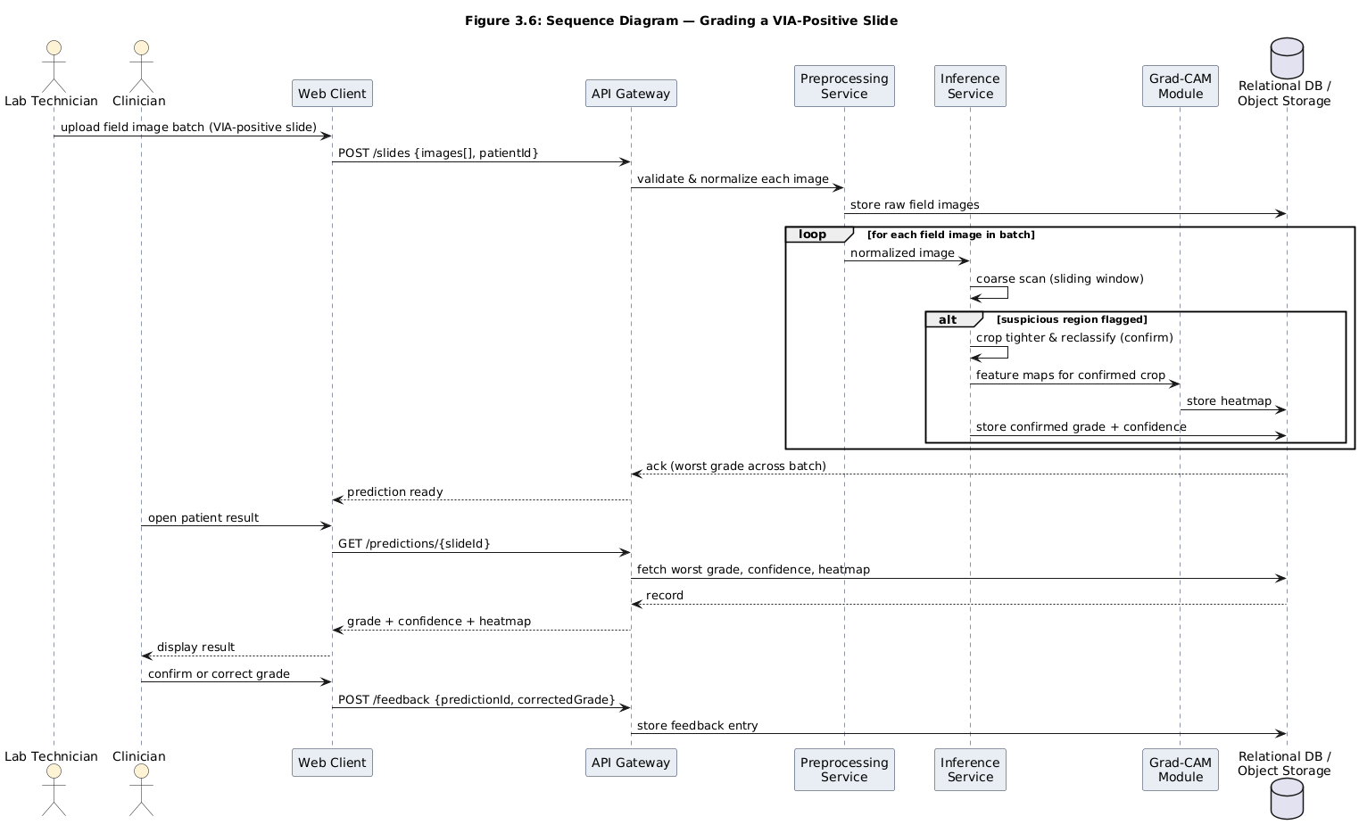
Figure 3.6. Sequence diagram for grading a VIA-positive slide.
Figure 3.6 traces one patient's batch of field images through the system: upload, preprocessing, and then, for each image, a coarse scan for suspicious regions and, where one is found, a confirmation pass that crops and reclassifies it, generates its Grad-CAM heatmap, and stores the result. Once every image in the batch has been checked, the single most severe confirmed grade is returned as the patient's result, to the clinician opening it and submitting feedback. The diagram stops at feedback storage rather than showing a retraining trigger, since automatic retraining from clinician feedback is future work rather than a mechanism this project builds and evaluates.

3.9 Development Tools
The prototype is built entirely on free or open-source tools, consistent with the trimmed research budget in Section 1.7. Models are developed in Python using TensorFlow/Keras (or PyTorch, selected once initial trials are complete) with the pre-trained EfficientNetB0, ConvNeXt, and RegNet weights available in each framework's model zoo, PLIP's published weights from Hugging Face, scikit-learn for PLIP's linear-probe classifier, and torchcam or a comparable library for the Grad-CAM layer. Training and comparison runs are tracked in Jupyter notebooks on Google Colab, using its free or Pro-tier GPU access. The serving side is a FastAPI backend, chosen for its native async support and automatic request validation, paired with a React web client for the lab technician and clinician screens described in Section 3.4. The sliding-window scan and crop-and-confirm step described there reuse the same trained classifier and image libraries already in the stack, rather than adding a separate detection framework. Data is stored in PostgreSQL, with raw slide images and model checkpoints kept in object storage (a local filesystem for the prototype, with a cloud bucket such as Amazon S3 or Backblaze B2 as the production equivalent). The application is containerized with Docker so the same environment runs in development and on the hosting provider named in the budget. Version control is Git and GitHub, and the four UML diagrams and system architecture diagram in this chapter were produced with Graphviz and PlantUML rather than a generic AI image generator, specifically so their notation could be checked by hand against the UML specification rather than assumed correct.

References
Abinaya, K., & Sivakumar, B. (2024). A deep learning-based approach for cervical cancer classification using 3D CNN and vision transformer. Journal of Imaging Informatics in Medicine. https://pmc.ncbi.nlm.nih.gov/articles/PMC11266342/
Amershi, S., Begel, A., Bird, C., DeLine, R., Gall, H., Kamar, E., Nagappan, N., Nushi, B., & Zimmermann, T. (2019). Software engineering for machine learning: A case study. In Proceedings of the 41st International Conference on Software Engineering: Software Engineering in Practice (ICSE-SEIP) (pp. 291-300). IEEE. https://doi.org/10.1109/ICSE-SEIP.2019.00042
Chandran, V., Sumithra, M. G., Karthick, A., et al. (2021). Diagnosis of cervical cancer based on ensemble deep learning network using colposcopy images. BioMed Research International. https://onlinelibrary.wiley.com/doi/10.1155/2021/5584004
Cheng, S., Liu, S., Yu, J., et al. (2021). Robust whole slide image analysis for cervical cancer screening using deep learning. Nature Communications. https://www.nature.com/articles/s41467-021-25296-x
Cleveland Clinic. (n.d.). Pap smear. https://my.clevelandclinic.org/health/diagnostics/4267-pap-smear
Desai, K. T., et al. (2022). The development of “automated visual evaluation” for cervical cancer screening: The promise and challenges in adapting deep-learning for clinical testing. International Journal of Cancer. https://pubmed.ncbi.nlm.nih.gov/34800038/
Gulshan, V., Peng, L., Coram, M., et al. (2016). Development and validation of a deep learning algorithm for detection of diabetic retinopathy in retinal fundus photographs. JAMA, 316(22), 2402-2410. https://doi.org/10.1001/jama.2016.17216
Harsono, I. W., et al. (2022). Cervical pre-cancerous lesion detection: Development of smartphone-based VIA application using artificial intelligence. BMC Research Notes. https://link.springer.com/article/10.1186/s13104-022-06250-6
Himabindu, D. D., Lydia, E. L., Rajesh, M. V., Ahmed, M. A., & Ishak, M. K. (2025). Leveraging swin transformer with ensemble of deep learning model for cervical cancer screening using colposcopy images. Scientific Reports, 15, Article 7900. https://doi.org/10.1038/s41598-025-90415-3
HPV Information Centre. (2023). Human papillomavirus and related diseases report: Rwanda. ICO/IARC Information Centre on HPV and Cancer. https://hpvcentre.net/statistics/reports/RWA.pdf
Hu, L., Bell, D., Antani, S., et al. (2019). An observational study of deep learning and automated evaluation of cervical images for cancer screening. JNCI: Journal of the National Cancer Institute, 111(9), 923-932. https://academic.oup.com/jnci/article/111/9/923/5272614
Hu, L., Horning, M. P., Banik, D., et al. (2020). Deep learning-based image evaluation for cervical precancer screening with a smartphone targeting low resource settings—Engineering approach. https://pubmed.ncbi.nlm.nih.gov/33018383/
Hu, L., et al. (2024). Internal validation of automated visual evaluation (AVE) on smartphone images for cervical cancer screening in a prospective study in Zambia. Cancer Medicine. https://www.medrxiv.org/content/10.1101/2023.07.19.23292888v3
Huang, J., Li, G., Kan, S., Liu, J., & Liang, Y. (2024). An efficient framework based on large foundation model for cervical cytopathology whole slide image screening. arXiv. https://arxiv.org/abs/2407.11486
Huang, Z., Bianchi, F., Yuksekgonul, M., Montine, T. J., & Zou, J. (2023). A visual-language foundation model for pathology image analysis using medical Twitter. Nature Medicine. https://pubmed.ncbi.nlm.nih.gov/37592105/
Hussain, E., Mahanta, L. B., Das, C. R., & Talukdar, R. K. (2020). Liquid based-cytology Pap smear dataset for automated multi-class diagnosis of pre-cancerous and cervical cancer lesions. Data in Brief, Article 105589. https://doi.org/10.1016/j.dib.2020.105589
Jantzen, J., Norup, J., Dounias, G., & Bjerregaard, B. (2005). Pap-smear benchmark data for pattern classification [Technical report]. Technical University of Denmark, Oersted-DTU, Automation.
Jiang, P., Li, X., Shen, H., Chen, Y., Wang, L., Chen, H., Feng, J., & Liu, J. (2023). A systematic review of deep learning-based cervical cytology screening: From cell identification to whole slide image analysis. Artificial Intelligence Review, 56(2), 2687-2758. https://link.springer.com/article/10.1007/s10462-023-10588-z
Kurita, T., et al. (2024). Enhancing cervical cancer cytology screening via artificial intelligence innovation. Scientific Reports, 14, 19535. https://www.nature.com/articles/s41598-024-70670-6
Mohammadi, A., et al. (2024). Automated reporting of cervical biopsies using artificial intelligence. PLOS Digital Health, 3(4), e0000381. https://journals.plos.org/digitalhealth/article?id=10.1371/journal.pdig.0000381
NHS England. (2017). Achieving a 14 day turnaround time in cytology. https://www.england.nhs.uk/improvement-hub/wp-content/uploads/sites/44/2017/11/Achieving-a-14-day-turnaround-time-in-Cytology.pdf
Plissiti, M. E., Dimitrakopoulos, P., Sfikas, G., Nikou, C., Krikoni, O., & Charchanti, A. (2018). SIPaKMeD: A new dataset for feature and image based classification of normal and pathological cervical cells in Pap smear images. In 2018 IEEE International Conference on Image Processing (ICIP) (pp. 3144-3148). IEEE. https://doi.org/10.1109/ICIP.2018.8451588
Rezende, M. T., Silva, R., Bernardo, F. de O., Tobias, A. H. G., Oliveira, P. H. C., Machado, T. M., Costa, C. S., Medeiros, F. N. S., Ushizima, D. M., Carneiro, C. M., & Bianchi, A. G. C. (2021). CRIC Searchable Image Database as a public platform for conventional Pap smear cytology data. Scientific Data, 8, Article 151. https://doi.org/10.1038/s41597-021-00933-8
Ruzigana, G., Bazzet-Matabele, L., Rulisa, S., Martin, A. N., & Ghebre, R. G. (2017). Cervical cancer screening at a tertiary care center in Rwanda. Gynecologic Oncology Reports, 21, 83-86. https://www.sciencedirect.com/science/article/pii/S2352578917300565
Rwanda Biomedical Centre. (2020). Rwanda National Cancer Control Plan: 2020-2024. https://www.rbc.gov.rw/fileadmin/user_upload/result/Rwanda_NCCP_Final_Signed.pdf
Rwanda Biomedical Centre. (n.d.). Taking action, saving our women: Reducing cervical cancer incidence in Rwanda by increased screening and treating. Public Health Bulletin. https://rbc.gov.rw/publichealthbulletin/articles/read/121/
Rwanda Ministry of Health. (2024). Rwanda launches national strategy for cervical cancer elimination by 2027. https://www.moh.gov.rw/news-detail/rwanda-launches-national-strategy-for-cervical-cancer-elimination-by-2027
Salehi, A. W., Khan, S., Gupta, G., Alabduallah, B. I., Almjally, A., Alsolai, H., Siddiqui, T., & Mellit, A. (2023). A study of CNN and transfer learning in medical imaging: Advantages, challenges, future scope. Sustainability, 15(7), Article 5930. https://doi.org/10.3390/su15075930
Sparr, M. (2024). End-to-end MLOps pipeline with comparative model training [Diagram]. Reference architecture adapted for this proposal's Figure 3.1.
Stanek-Widera, A., Borowczak, J., Skiba, D., Mickael, M.-E., Łazarczyk, M., Maniewski, M., Szylberg, Ł., Bychkov, A., & Religa, P. (2026). Artificial intelligence in cervical cytology: Opportunities and limitations in screening, triage, and diagnostic support. Diagnostics, 16(10), 1541. https://doi.org/10.3390/diagnostics16101541
Stegmüller, T., Abbet, C., Bozorgtabar, B., Clarke, H., Petignat, P., Vassilakos, P., & Thiran, J.-P. (2023). Self-supervised learning-based cervical cytology for the triage of HPV-positive women in resource-limited settings and low-data regime. arXiv. https://arxiv.org/abs/2302.05195
Tang, J., Zhang, T., Gong, Z., & Huang, X. (2023). High precision cervical precancerous lesion classification method based on ConvNeXt. Bioengineering, 10(12), Article 1424. https://doi.org/10.3390/bioengineering10121424
Tran, H.-D.-N., Pham, T.-P., Trinh, M.-H., Ngo, T.-N., & Pham, H.-A. (2026). Grad-CAM-driven explainable deep learning framework for cervical cancer image classification. In Multi-disciplinary trends in artificial intelligence (MIWAI 2025), Lecture Notes in Computer Science (Vol. 16353). Springer. https://link.springer.com/chapter/10.1007/978-981-95-4957-3_25
Umulisa, M. C., Franceschi, S., Baussano, I., et al. (2018). Evaluation of human-papillomavirus testing and visual inspection for cervical cancer screening in Rwanda. BMC Women's Health, 18, 59. https://link.springer.com/article/10.1186/s12905-018-0549-5
U.S. Department of Health and Human Services. (1992). Clinical Laboratory Improvement Amendments of 1988: Cytology proficiency testing and workload limitations (42 C.F.R. § 493.851). https://www.ecfr.gov/current/title-42/chapter-IV/subchapter-G/part-493
Vani, M. S., & Rama Rao, N. (2025). Introducing the enhanced cervical cancer detection model PapEMS-Net, integrating EfficientNet, multi-verse optimizer, and softmax entropy classifier. Engineering, Technology & Applied Science Research, 15(6). https://doi.org/10.48084/etasr.12917
World Health Organization. (2021). WHO guideline for screening and treatment of cervical pre-cancer lesions for cervical cancer prevention. https://www.who.int/publications/i/item/9789240030824
World Health Organization. (2026). Cervical cancer. https://www.who.int/news-room/fact-sheets/detail/cervical-cancer
Wu, T., Lucas, E., Zhao, F., Basu, P., & Qiao, Y. (2024). Artificial intelligence strengthens cervical cancer screening—present and future. Cancer Biology & Medicine, 21(10), 864-879. https://www.cancerbiomed.org/content/21/10/864

